Lab Guide Vol3 Module 01: Session Hijacking

Scenario
A session hijacking attack refers to the exploitation of a session token-generation mechanism or token security controls that enables an attacker to establish an unauthorized connection with a target server. The attacker guesses or steals a valid session ID (which identifies authenticated users) and uses it to establish a session with the server.
As an ethical hacker or penetration tester, you should understand different session hijacking concepts, how attackers perform application- and network-level session hijacking, and the various tools used to launch this kind of attack. You should also be able to implement security measures at both the application and network levels to protect your network from session hijacking. Application-level hijacking involves gaining control over the Hypertext Transfer Protocol (HTTP) user session by obtaining the session IDs. Network-level hijacking is prevented by packet encryption, which can be achieved with protocols such as IPsec, SSL, and SSH.

Objective
The objective of the lab is to perform session hijacking and other tasks that include, but are not limited to:
- Hijack a session by intercepting traffic between server and client
- Steal a user session ID by intercepting traffic
- Detect session hijacking attacks

Overview of Session Hijacking
Session hijacking can be either active or passive, depending on the degree of involvement of the attacker:
- Active session hijacking: An attacker finds an active session and takes it over
- Passive session hijacking: An attacker hijacks a session, and, instead of taking over, monitors and records all the traffic in that session

Lab Tasks
Ethical hackers or penetration testers use numerous tools and techniques to perform session hijacking on the target systems. Recommended labs that will assist you in learning various session hijacking techniques include:
- Perform session hijacking
  - Hijack a session using Caido
  - Intercept HTTP traffic using Hetty
- Detect session hijacking
  - Detect session hijacking using Wireshark
Lab 1: Perform Session Hijacking
Lab Scenario
Session hijacking allows an attacker to take over an active session by bypassing the authentication process. It involves stealing or guessing a victim’s valid session ID, which the server uses to identify authenticated users, and using it to establish a connection with the server. The server responds to the attacker’s requests as though it were communicating with an authenticated user, after which the attacker is able to perform any action on that system.
Attackers can use session hijacking to launch various kinds of attacks such as man-in-the-middle (MITM) and Denial-of-Service (DoS) attacks. A MITM attack occurs when an attacker places himself/herself between the authorized client and the server to intercept information flowing in either direction. A DoS attack happens when attackers sniff sensitive information and use it to make host or network resource unavailable to users, usually by flooding the target with requests until the system is overloaded.
As a professional ethical hacker or penetration tester, you must possess the required knowledge to hijack sessions in order to test the systems in the target network.
The labs in this exercise demonstrate how to hijack an active session between two endpoints.
Lab Objectives
- Hijack a session using Caido
- Intercept HTTP traffic using Hetty
Overview of Session Hijacking
Session hijacking can be divided into three broad phases:
- Tracking the Connection: The attacker uses a network sniffer to track a victim and host, or uses a tool such as Nmap to scan the network for a target with a TCP sequence that is easy to predict
- Desynchronizing the Connection: A desynchronized state occurs when a connection between the target and host has been established, or is stable with no data transmission, or when the server’s sequence number is not equal to the client’s acknowledgment number (or vice versa)
- Injecting the Attacker’s Packet: Once the attacker has interrupted the connection between the server and target, they can either inject data into the network or actively participate as the man-in-the-middle, passing data between the target and server, while reading and injecting data at will
Task 1: Hijack a Session using Caido
Caido assists security professionals and enthusiasts in efficiently auditing web applications. It offers exploration tools, including sitemap, history, and intercept features, which aid in identifying vulnerabilities and analyzing requests in real-time. Users can modify incoming requests using Forward and Tamper tools, enhancing testing customization and system security comprehension. Automation is facilitated through the Automate tool, allowing for faster vulnerability discovery by testing requests against large wordlists. Caido's intuitive UI simplifies security testing for both novices and experts with clear navigation and user-friendly controls.
Here, we will use Caido to perform session hijacking on the target machine.
Before starting this task, we need to configure the proxy settings in the victim’s machine, which in this task will be the Windows Server 2019 machine.
- Click Windows 11 to switch to the Windows 11 machine. Login using Admin/Pa$$w0rd.
- Click windows Search icon on the Desktop; search for cmd and launch Command Prompt from search bar.
- Run ipconfig/flushdns command to reset dns cache and close the Command Prompt.
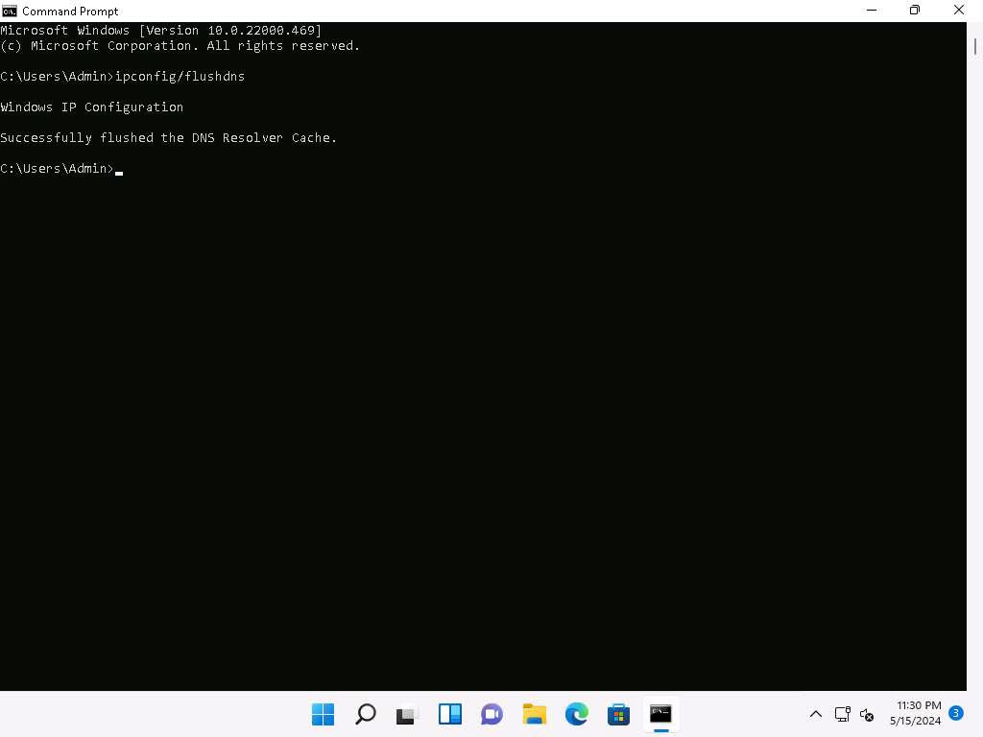
- Click windows Search icon on the Desktop; search for Caido and launch Caido from search bar.
- Caido application window appears. Click on menu besides Start button and select Edit.
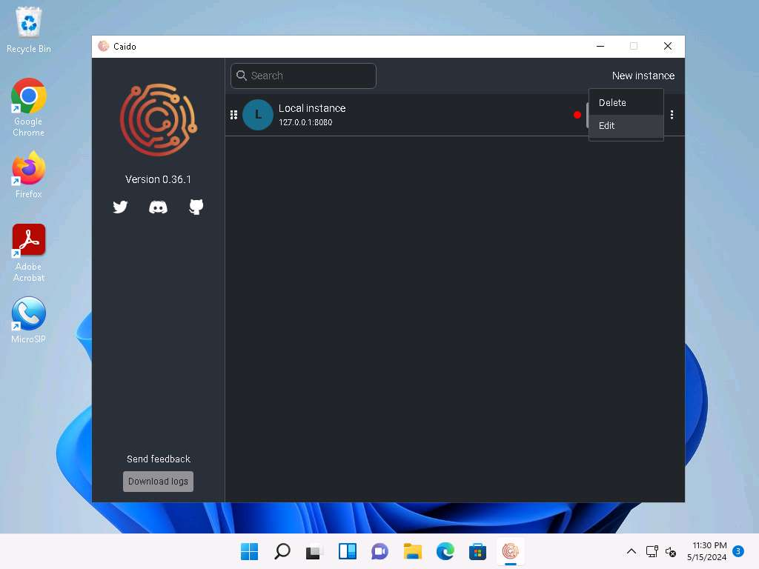
- In Edit Instance window, click on the radio button besides All interfaces (0.0.0.0) to listen on all the available network interfaces and click on Save.
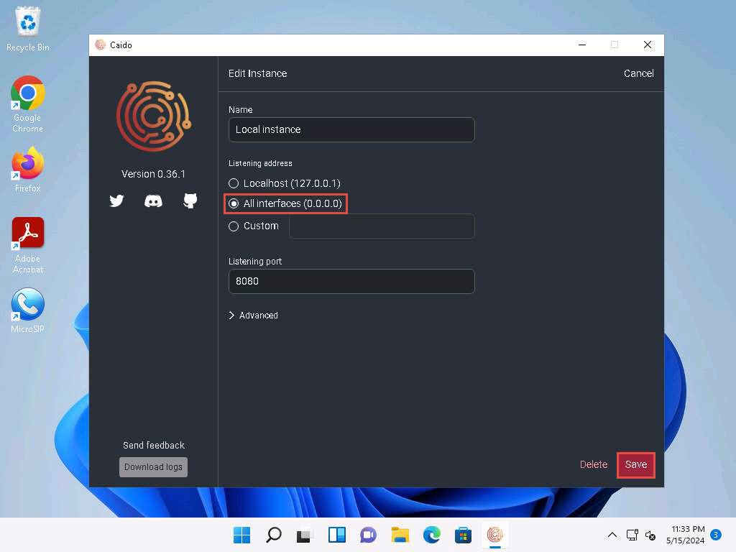
- Click on Start button to start the local instance.
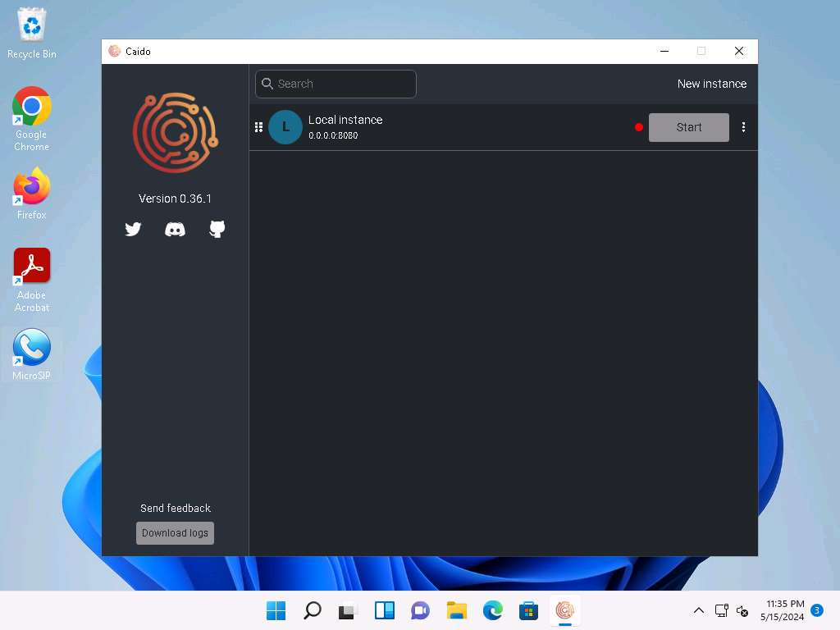
- Welcome to Caido pop-up appears. Click on Login if you have an account already. If not, select Don't have an account?. You will be redirected to Dashboard.
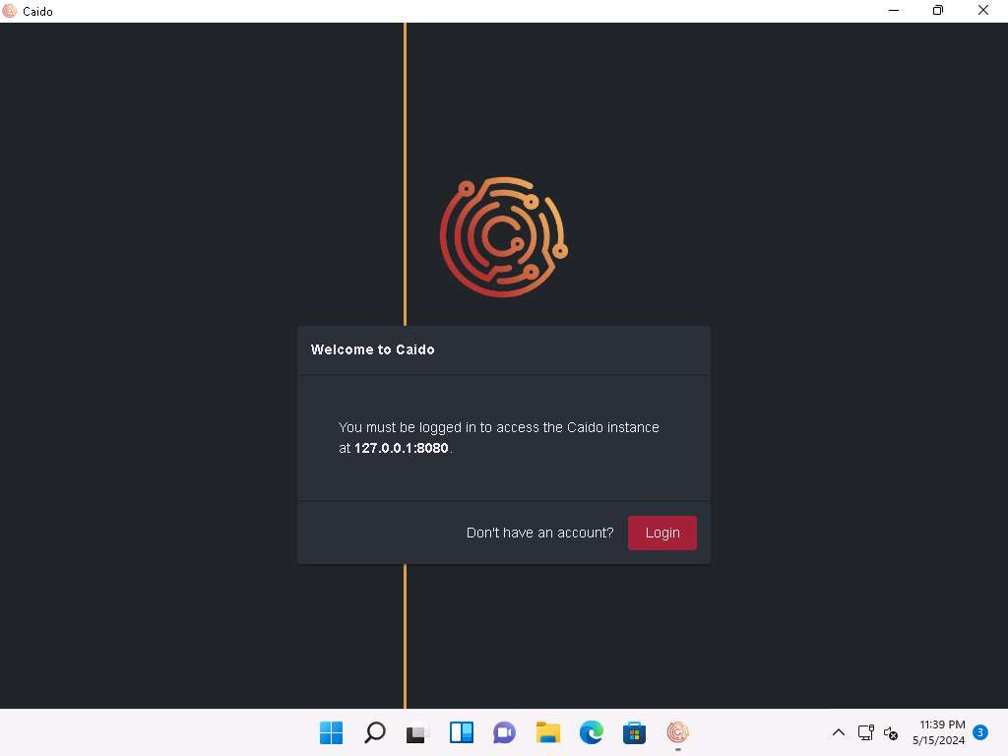
- Create an account window appears. Here, fill in the details and click on Create account.
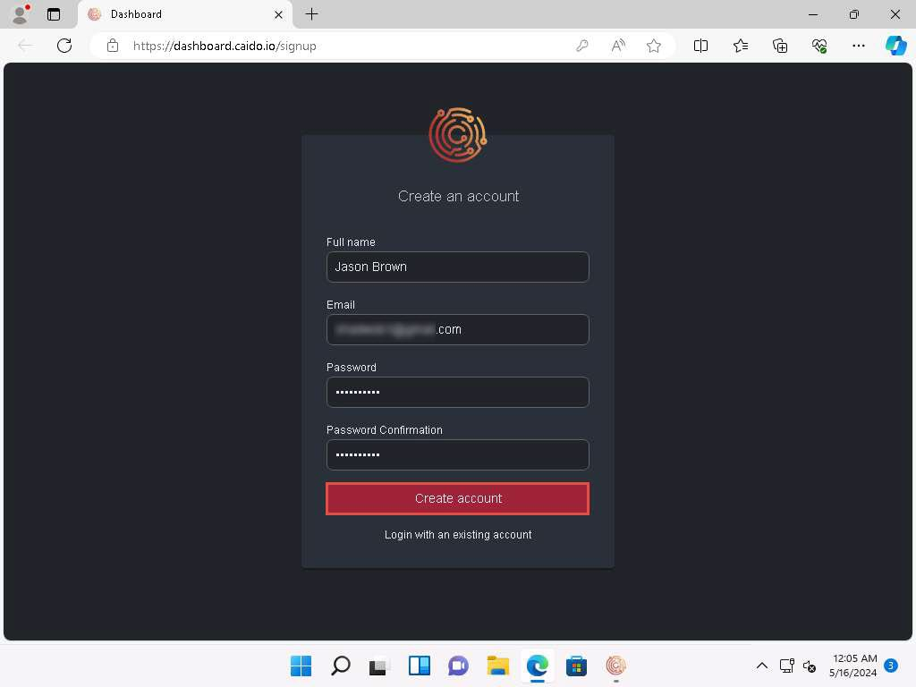
- Login to your mail account. You will receive a verification mail from Team Caido. Copy the code and paste it in the Caido verification window.
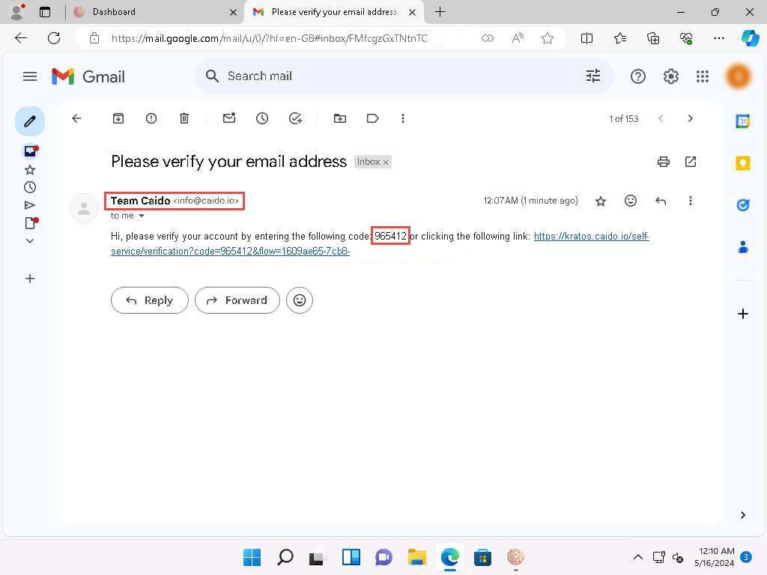
- After entering the code, your account will be activated as shown in the screenshot.
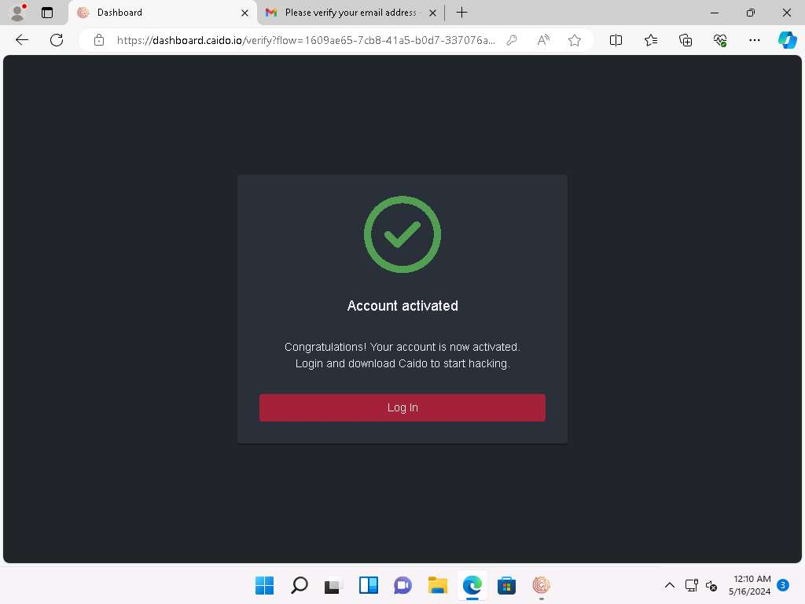
- Navigate back to Caido application. In Welcome to Caido pop-up click on Login.
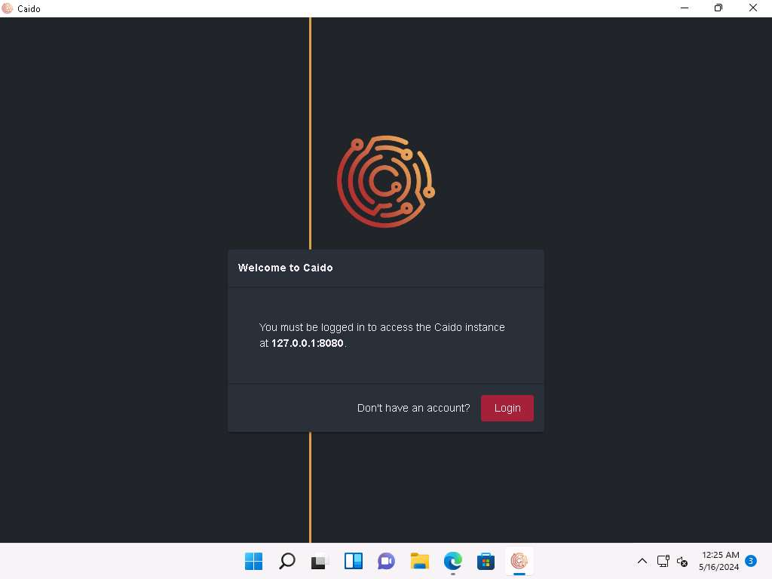
- Welcome to Caido page will appear. Enter your credentials and click Login.
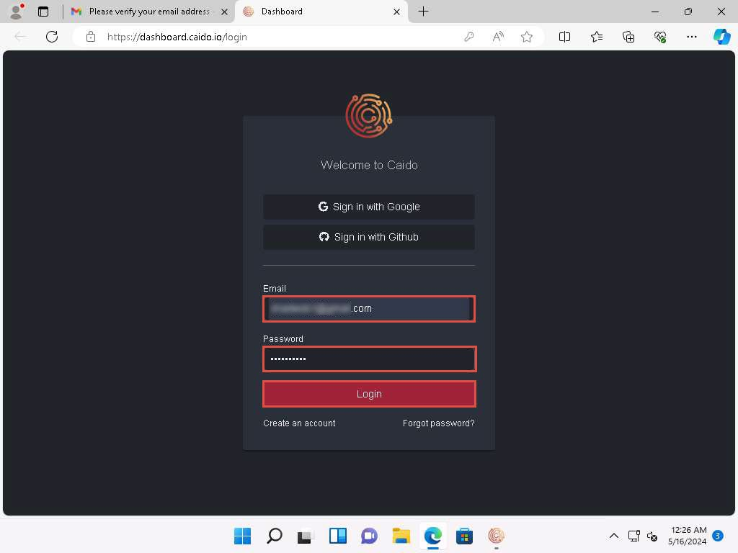
- Once logged in, Register your Caido Instance pop-up will appear. Type Session Hijacking and click Register.
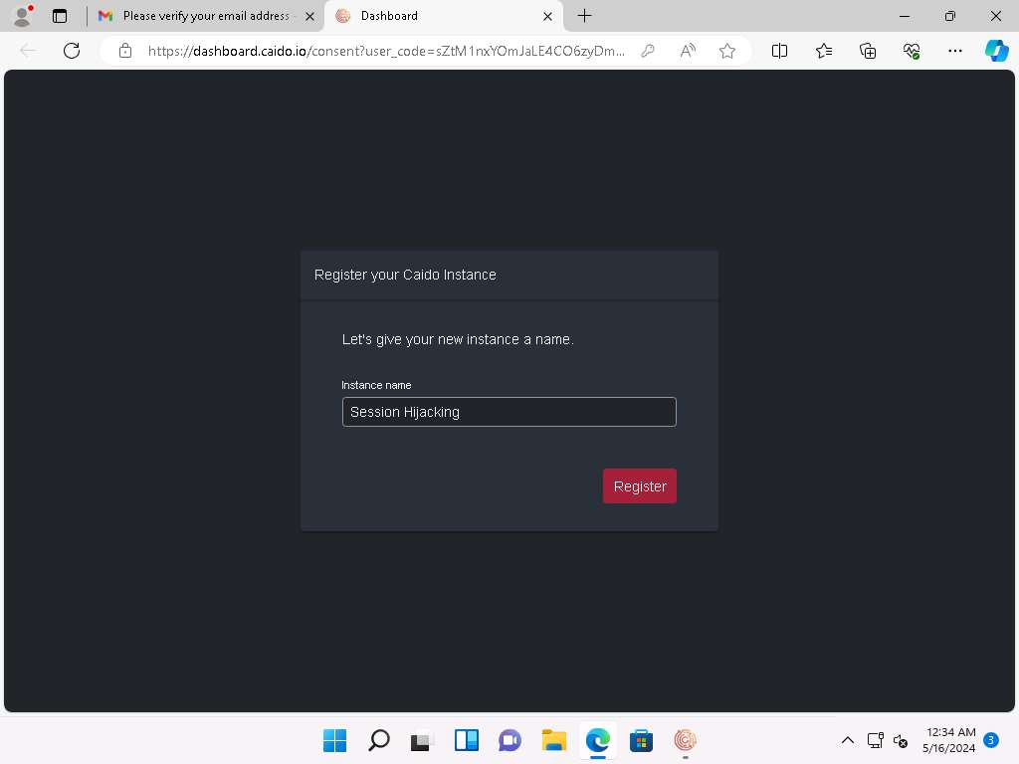
- Sign in with Caido window appears. Click Allow to allow the access. Authorization Complete! pop-up appears. Close the web browser and return to the application.
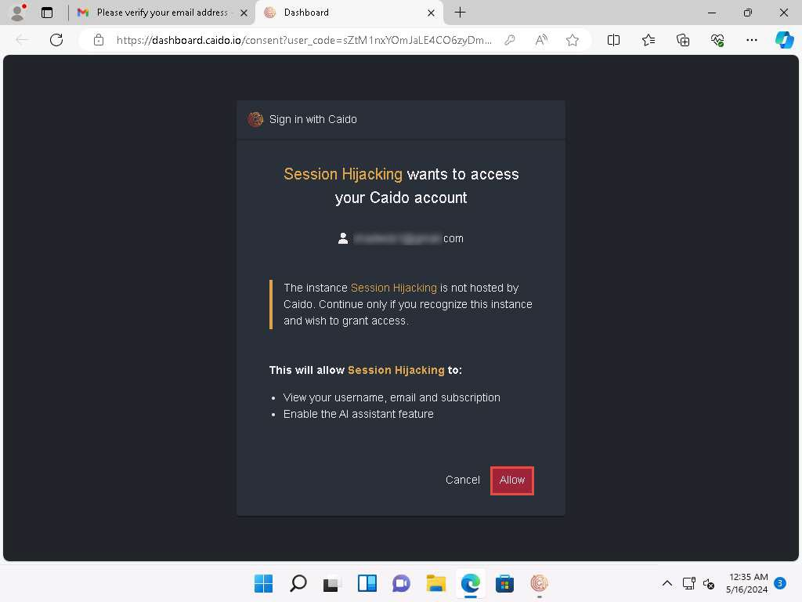
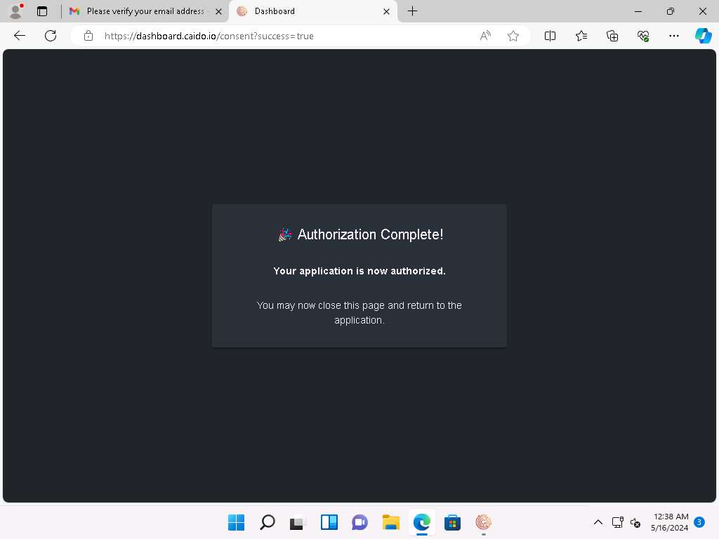
- The Caido main window appears.
If a Caido pop-up appears, click Next or Ok in all the pop-ups.
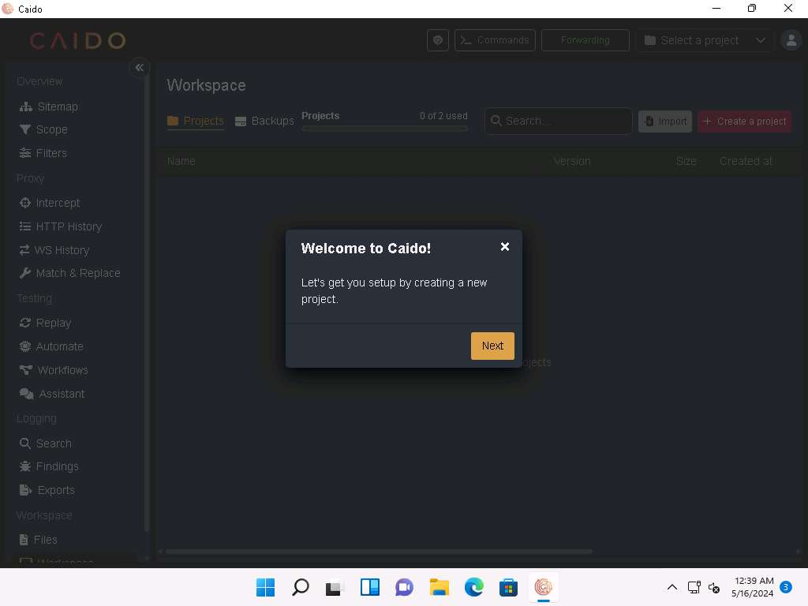
- Click on + Create a project button to create a new project. Create a project pop-up appears. Name it as Session Hijacking and click Create.
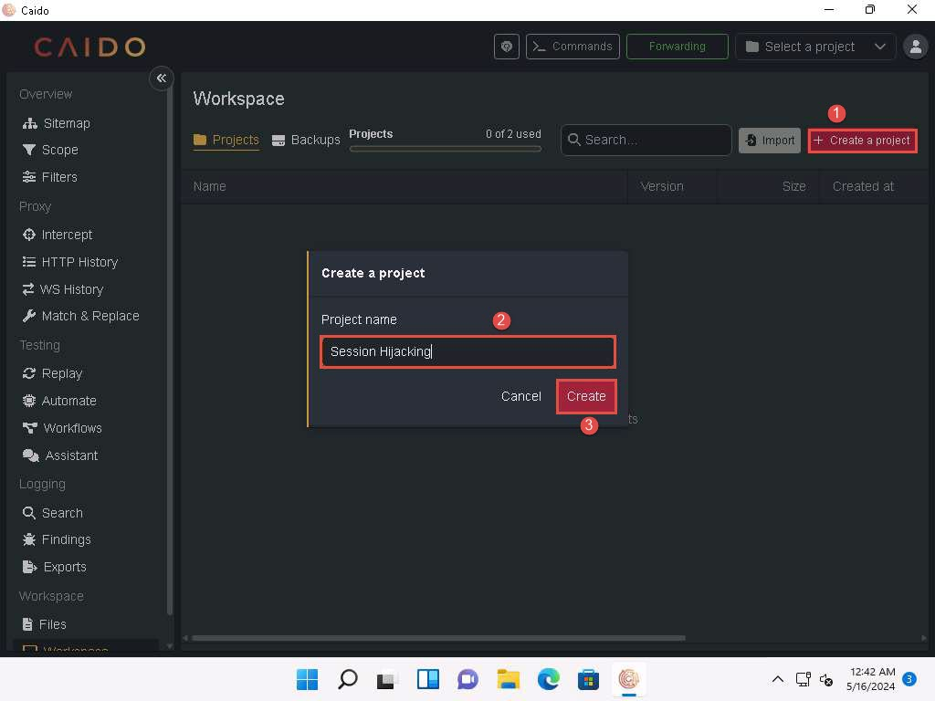
- Click on the Intercept option on the left pane, as shown in the screenshot below.
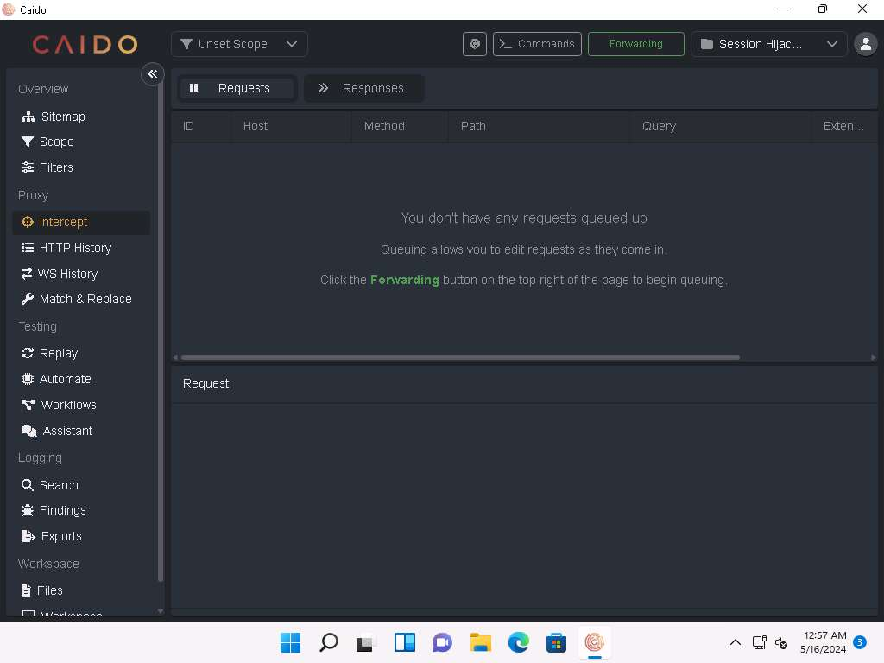
- Click the Forwarding icon and wait until it changes to Queuing. This button will trap and display the next response or request from the victim’s machine in the Intercept tab.
The Forwarding icon turns automatically from green to red.
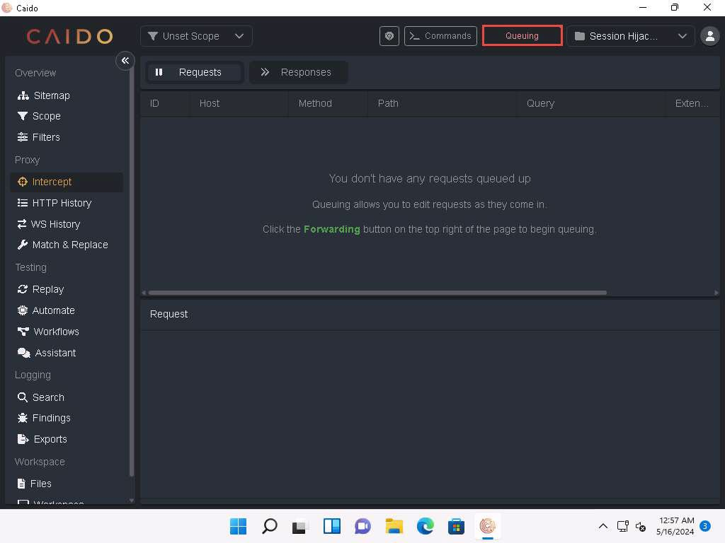
- Click Windows Server 2019 to switch to the Windows Server 2019 machine. Click Ctrl+Alt+Delete to activate the machine and login using Administrator/Pa$$w0rd.
Networks screen appears. Click Yes to allow your PC to be discoverable by other PCs and devices on the network.
- Open Firefox web browser and navigate to http://10.10.1.11:8080/ca.crt. CA certificate will be downloaded automatically as shown in the screenshot.
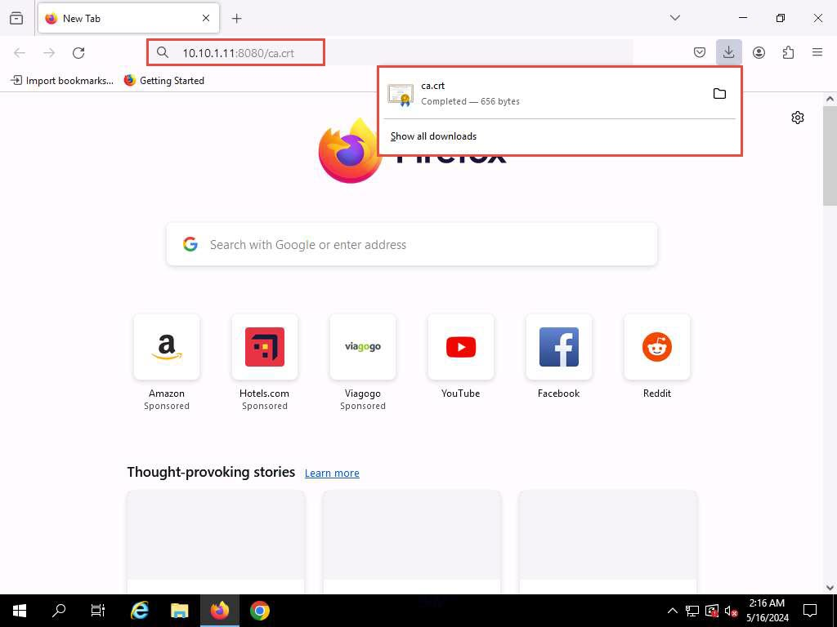
- In Firefox web browser, select Settings from the context menu.

- On the Settings page, search for Certificates and open View Certificates.
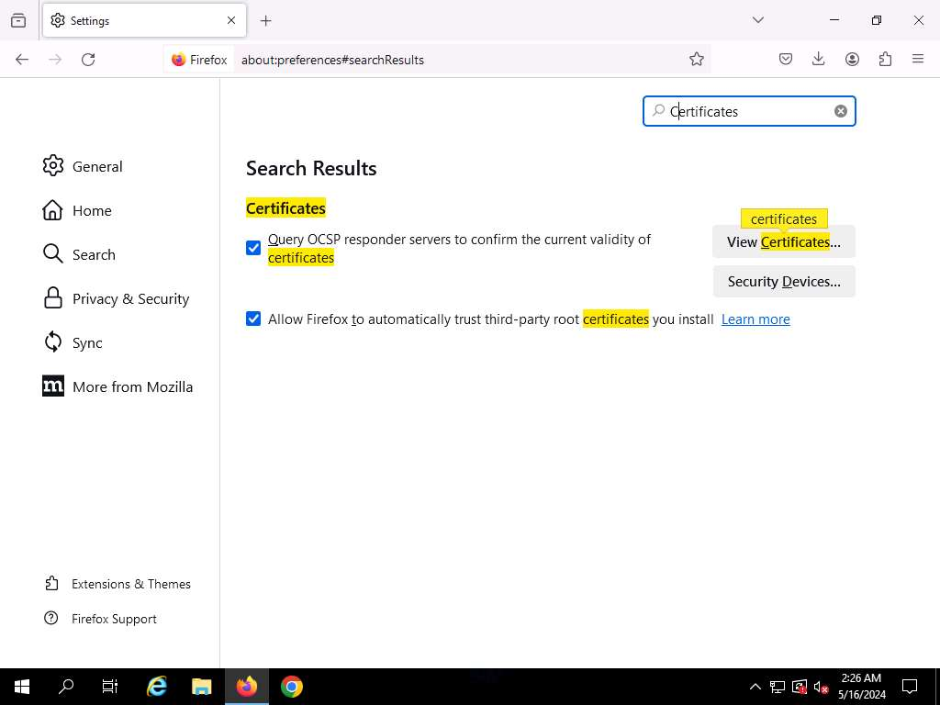
- Navigate to Authorities tab and click on Import…
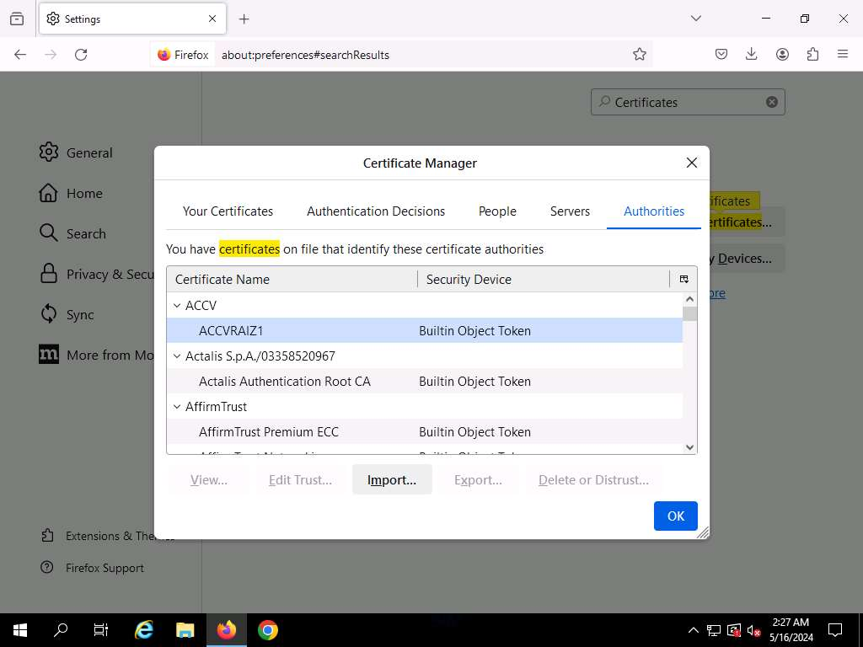
- In Select File containing CA certificate(s) to import window, select the recently downloaded ca.crt file and click Open.
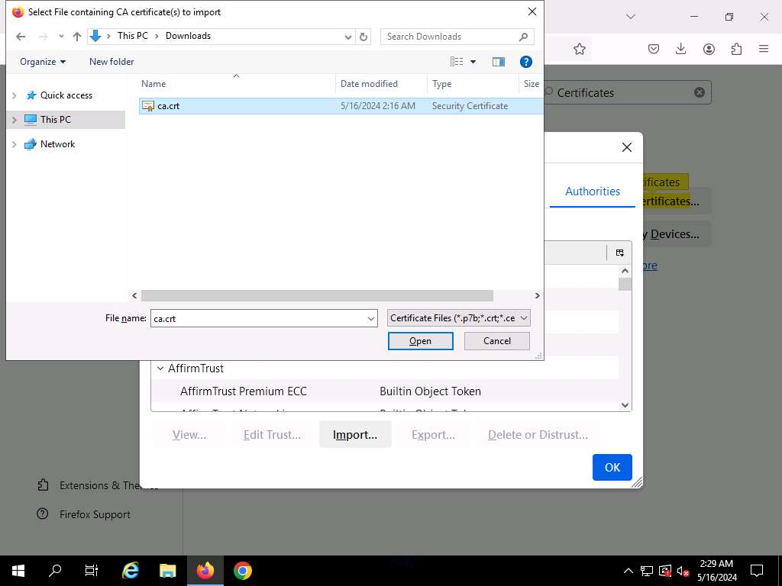
- When prompted, click the Trust this CA to identify websites checkbox and click on OK. Click OK in the Certificate Manager window.
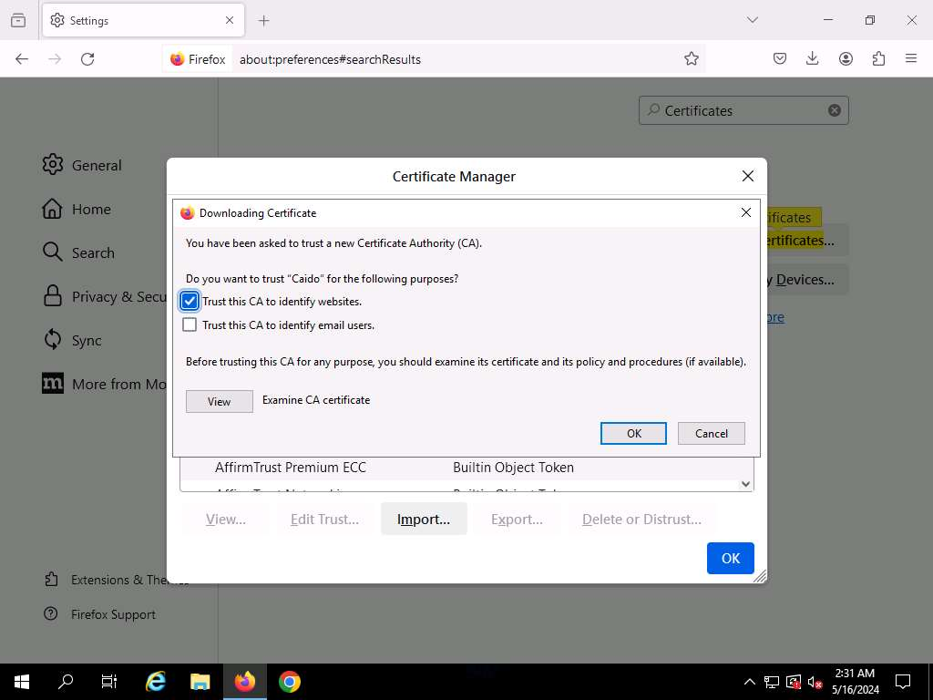
- On the Settings page, search for proxy and open it.
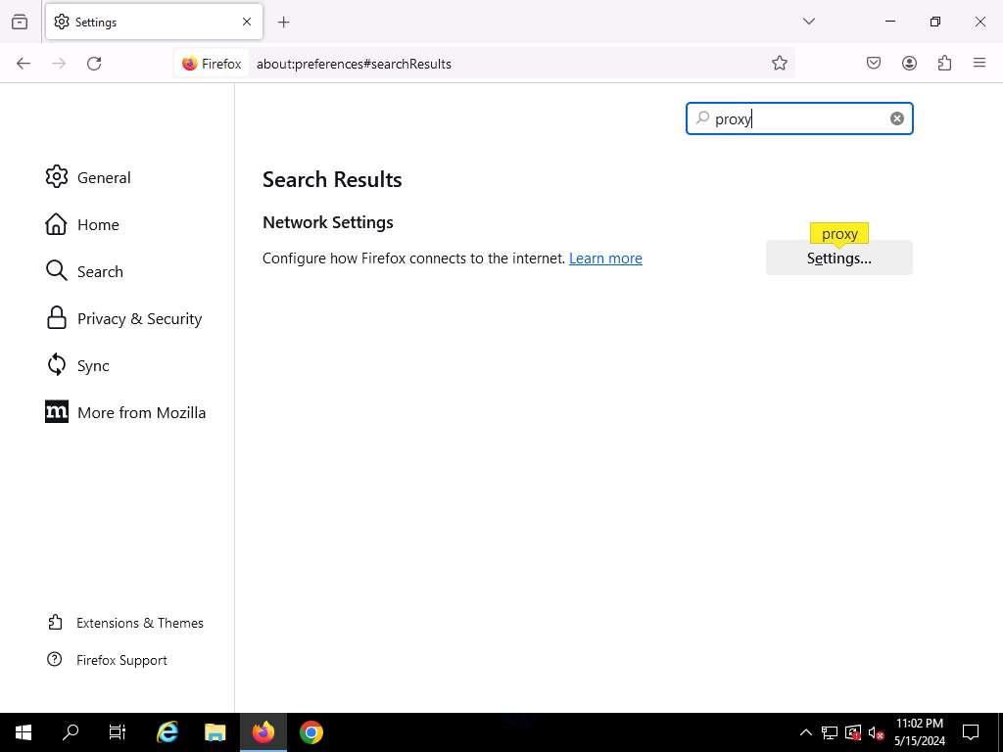
- Connection Settings page appears and click Manual proxy configuration to configure a proxy.
- Set HTTP Proxy to 10.10.1.11 and port to 8080. Check the Also use this proxy for HTTPS box and click OK.
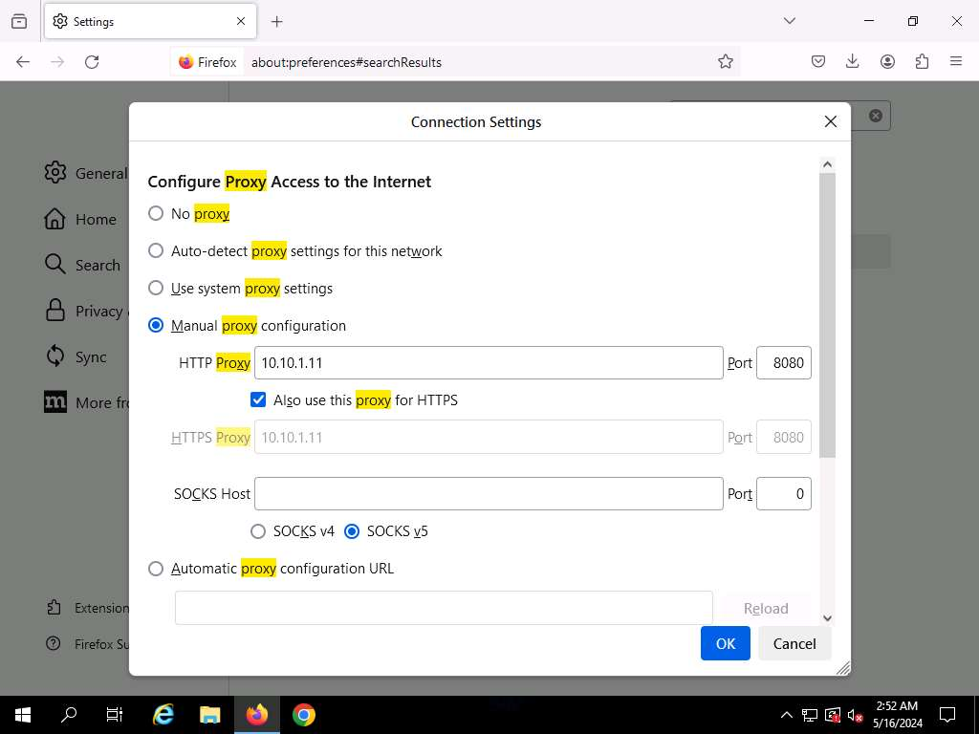
- After saving, close the Settings and browser windows. You have now configured the proxy settings of the victim’s machine.
- Open a new tab in Firefox web browser and place your mouse cursor in the address bar. Type www.moviescope.com and press Enter.
- If a message appears stating that Your connection is not private, click the Advanced button.
- On the next page, click Proceed to www.moviescope.com (unsafe) to open the website.
- Now, click Windows 11 to switch back to the attacker machine (Windows 11) and observe that Caido has begun to capture the requests of the victim’s machine.
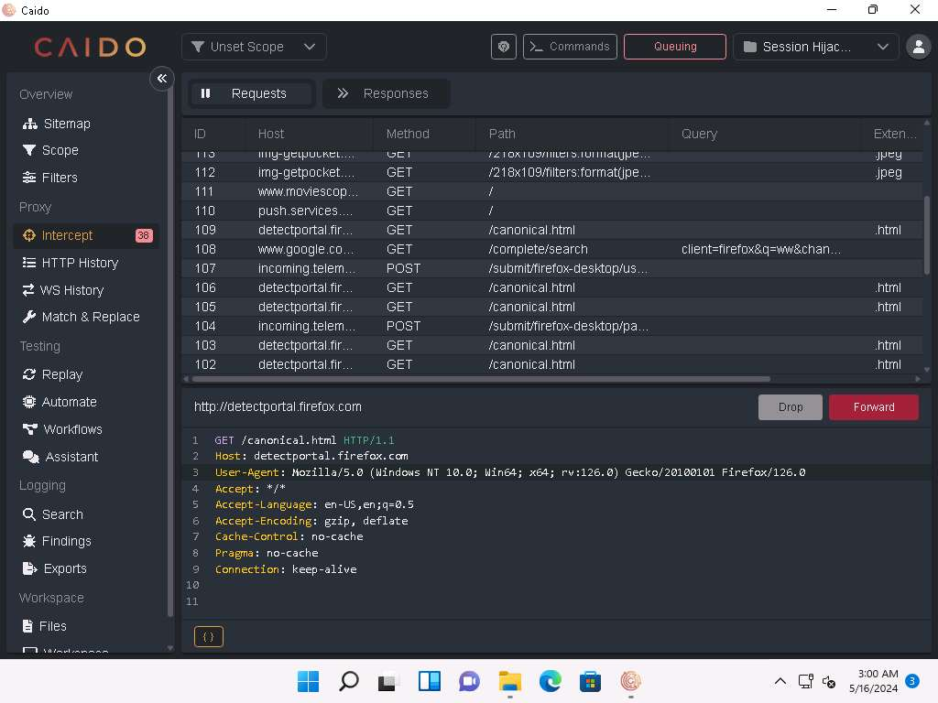
- On the Requests tab, for all www.moviescope.com requests, modify www.moviescope.com to www.goodshopping.com in all the captured GET requests and Forward all the requests.
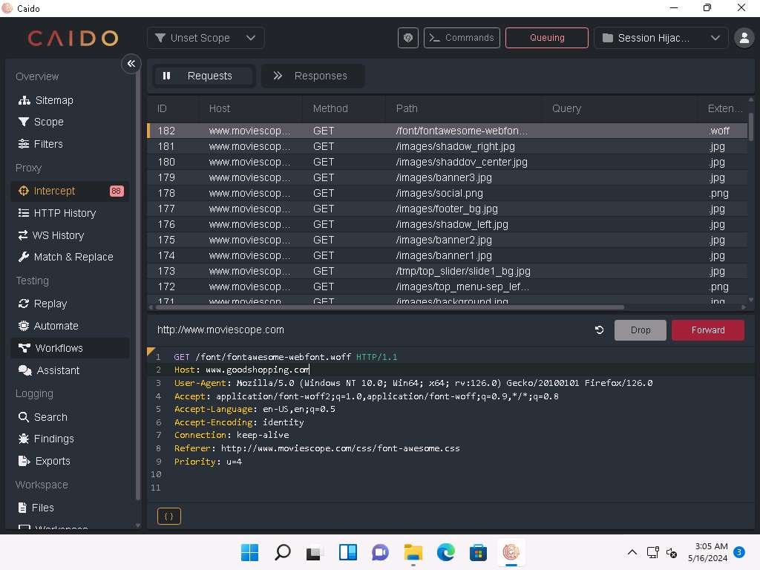
- In a similar way, modify every GET request captured by Caido until you see the www.goodshopping.com page in the victim’s machine. You will need to switch back and forth from the victim’s machine to see the browser status while you do this.
If you do not receive any requests or you see a blank Requests tab, then switch to Windows Server 2019 machine and refresh the browser to capture the request again.
- Now, click on Windows Server 2019 to switch to the victim’s machine (Windows Server 2019); the browser displays the website that the attacker wants the victim’s machine to see (in this example, www.goodshopping.com).
- The victim has navigated to www.moviescope.com but now sees www.goodshopping.com; while the address bar displays www. moviescope.com, the window displays www.goodshopping.com.

- Now, we shall change the proxy settings back to the default settings. To do so, in the Firefox browser, select Settings from the context menu. On the Settings page, search for proxy and open it. Connection Settings page appears, check No Proxy radio button and click OK.
- This concludes the demonstration of performing session hijacking using Caido.
- Close all open windows and document all the acquired information.
Question 11.1.1.1
Use Caido tool on the attacker machine (10.10.1.11) to hijack a session established when a user on the victim machine (10.10.1.19) visits the website www.moviescope.com and redirect to www.goodshopping.com using the Firefox browser.

Task 2: Intercept HTTP Traffic using Hetty
Hetty is an HTTP toolkit for security research. It aims to become an open-source alternative to commercial software such as Burp Suite Pro, with powerful features tailored to the needs of the InfoSec and bug bounty communities. Hetty can be used to perform Machine-in-the-middle (MITM) attack, manually create/edit requests, replay proxied requests for HTTP clients, and further intercept requests and responses for manual review.
Here, we will use the Hetty tool to intercept HTTP traffic on the target system.
Here, we will use Windows 11 machine as an attacker machine and Windows Server 2022 machine as a target machine.
- Click Windows 11 to switch to the Windows 11 machine.
- Navigate to E:\CEH-Tools\CEHv13 Module 11 Session Hijacking\Hetty and double-click hetty.exe.
If an Open File - Security Warning window appears, click Run.
- A Command Prompt window appears, and Hetty initializes.
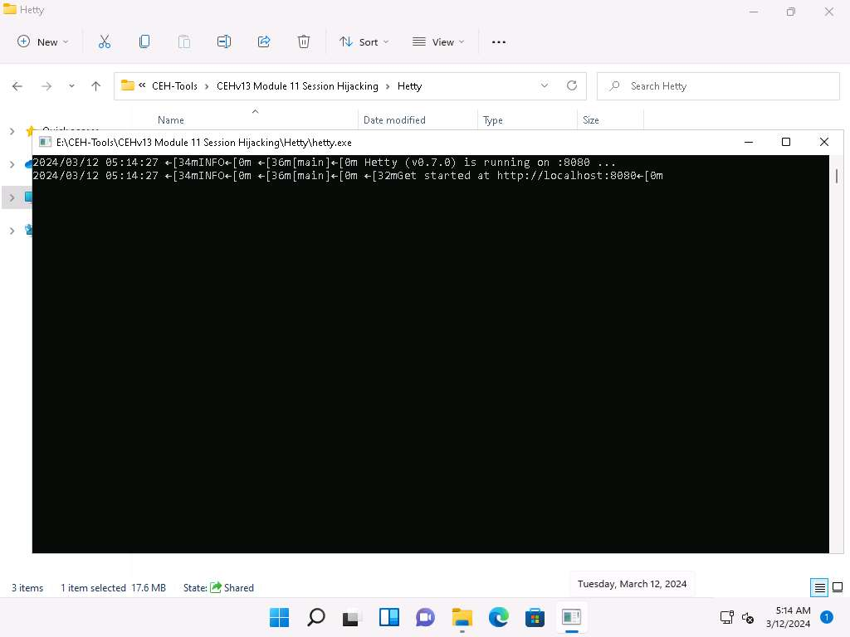
- Now, minimize all the windows and launch any web browser (here, Mozilla Firefox). Go to http://localhost:8080 to open Hetty dashboard.
- In the Hetty dashboard, click MANAGE PROJECTS button.
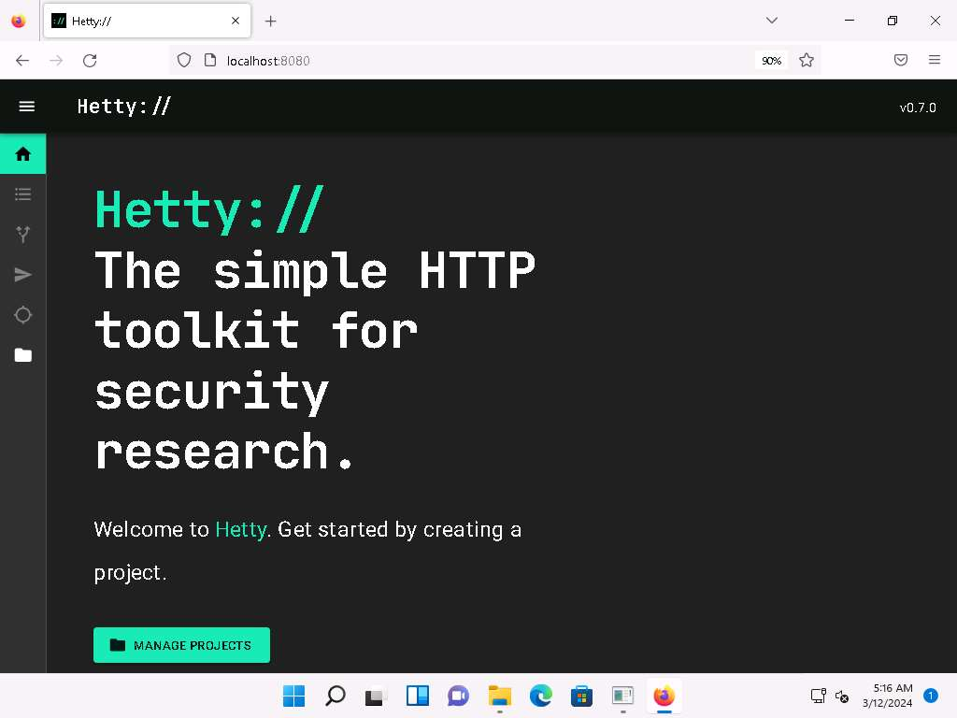
- Projects page appears. Type Project name as Moviescope and click + CREATE & OPEN PROJECT button.
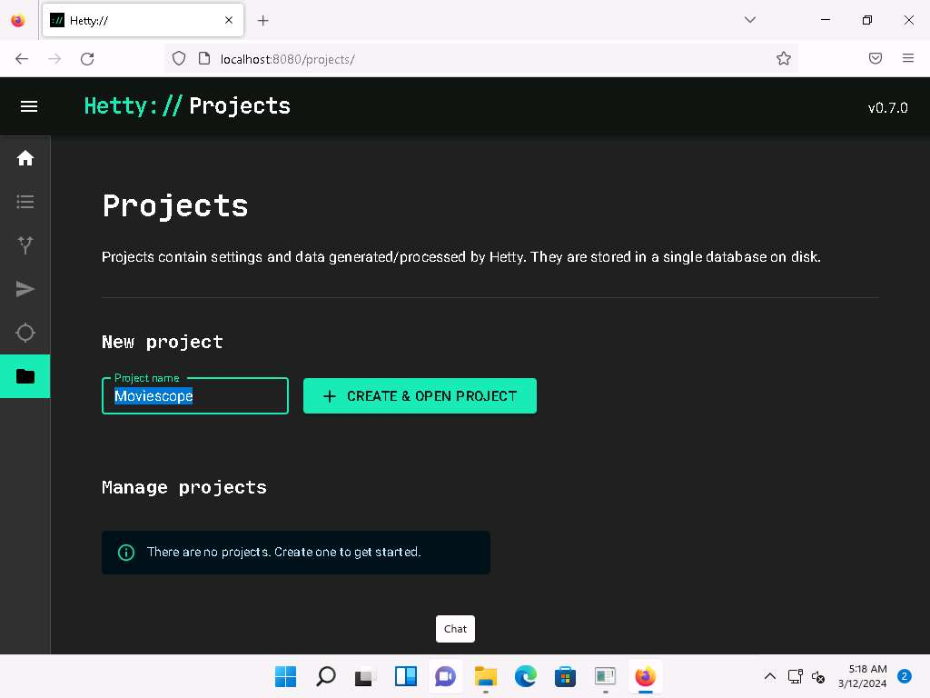
- You can observe that a new project named Moviescope has been created under Manage projects section with a status as Active.
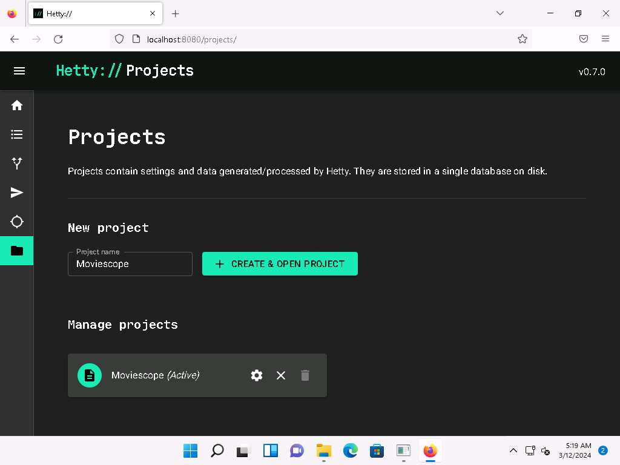
- Click Proxy logs icon ( )) from the left-pane.
- A Proxy logs page appears, as shown in the screenshot.
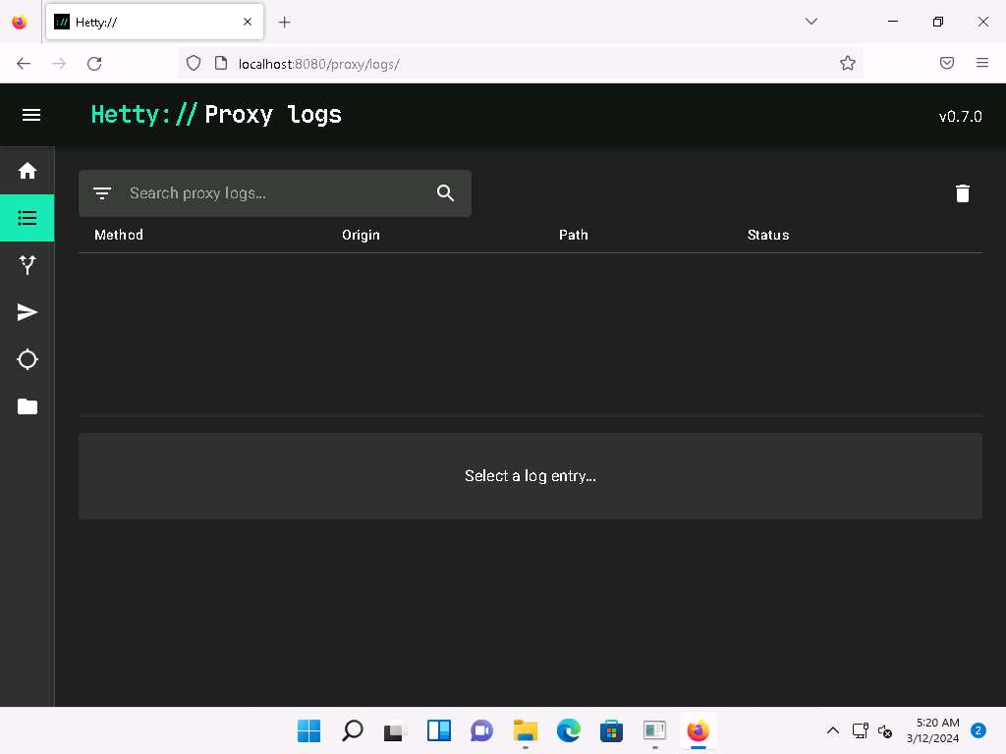
- Now, click Windows Server 2022 to switch to the Windows Server 2022 machine. Click Ctrl+Alt+Delete to activate the machine and login using Administrator/Pa$$w0rd.
Networks screen appears. Click Yes to allow your PC to be discoverable by other PCs and devices on the network.
- Open Google Chrome web browser, click the Customize and control Google Chrome icon, and select Settings from the context menu.
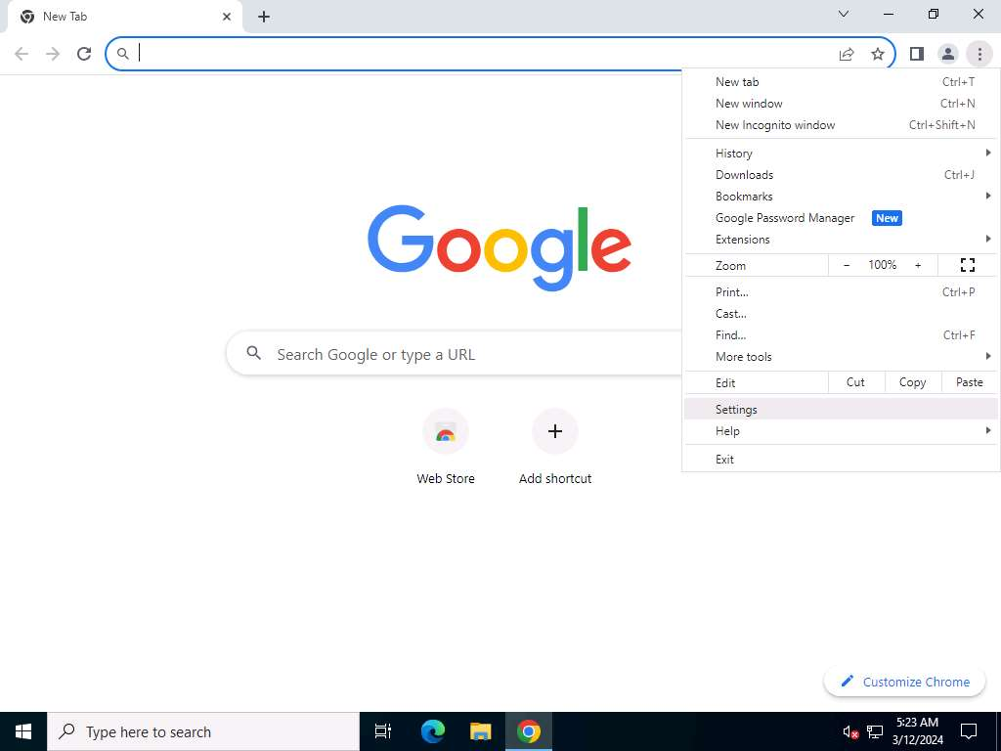
- On the Settings page, scroll down and click System in the left-pane.
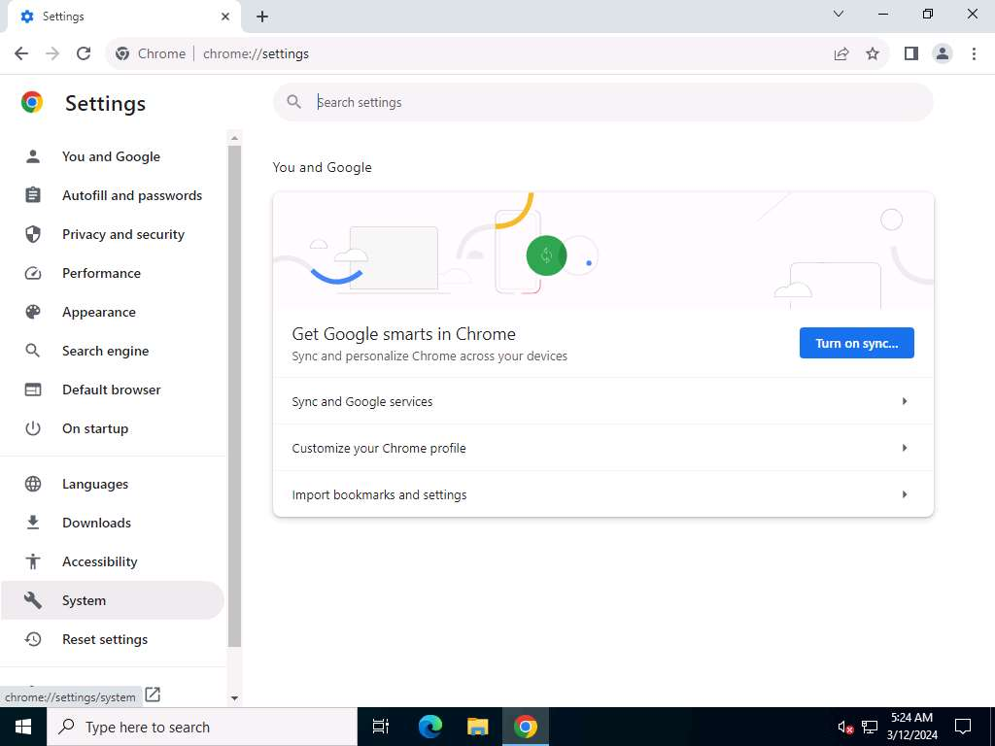
- Scroll down to the System section and click Open your computer’s proxy settings to configure a proxy.
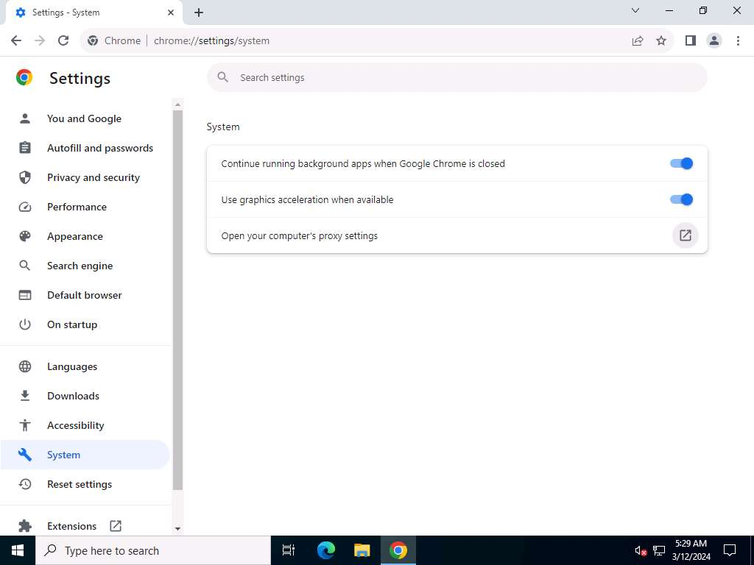
- A Settings window appears, with the Proxy settings in the right pane.
- In the Manual proxy setup section, make the following changes:
  - Under the Use a proxy server option, click the Off button to switch it On.
  - In the Address field, type 10.10.1.11 (the IP address of the attacker’s machine, here, Windows 11).
  - In the Port field, type 8080.
  - Click Save.
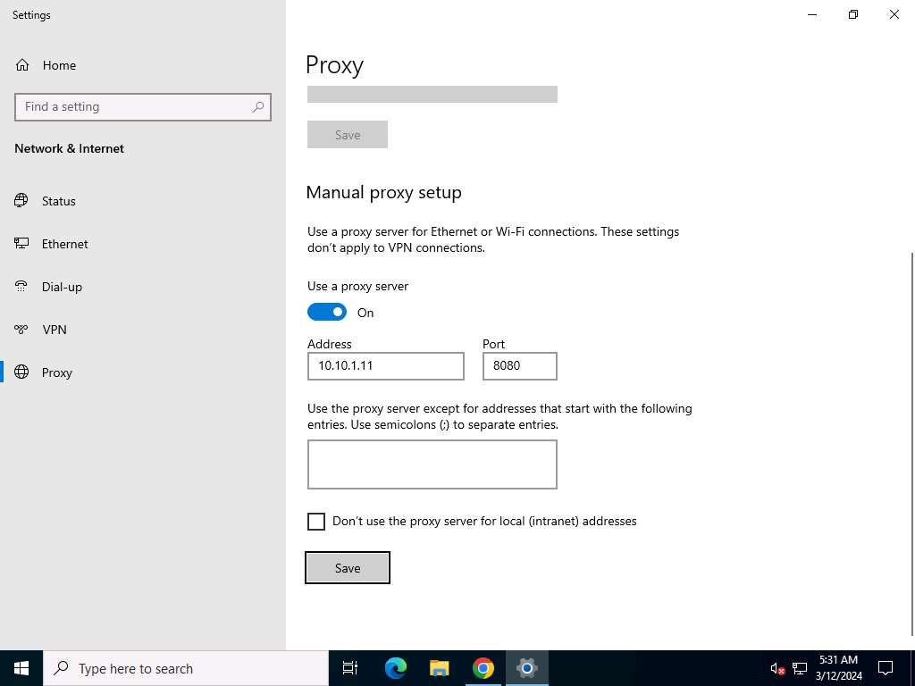
- After saving, close the Settings and browser windows. You have now configured the proxy settings of the victim’s machine.
- Now, in the web browser go to http://www.moviescope.com.
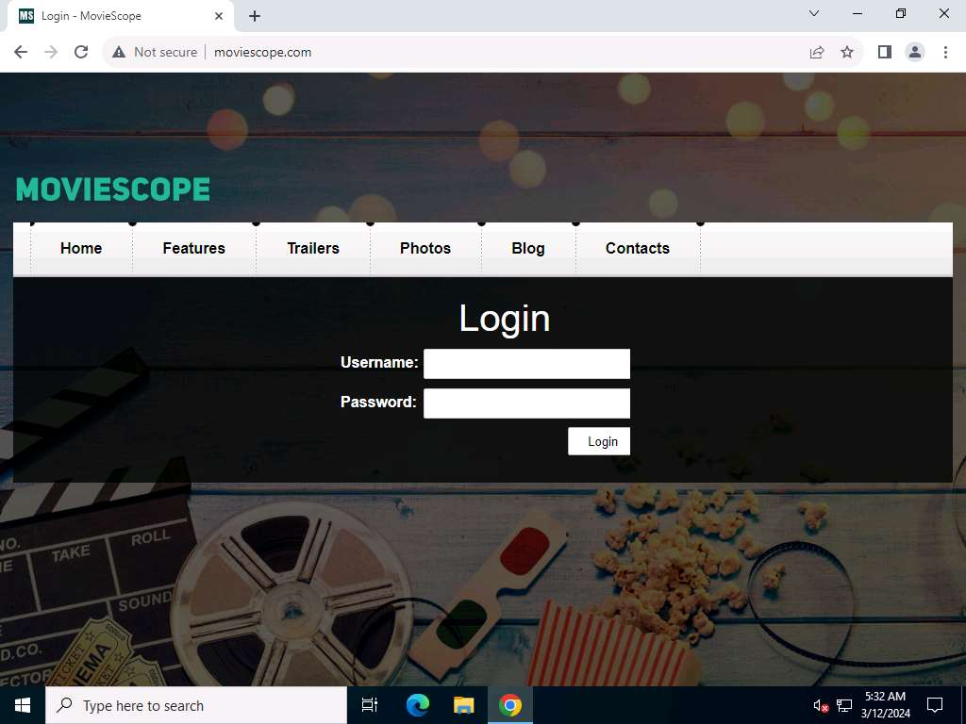
- Click Windows 11 to switch to the Windows 11 machine.
- You can observe that the logs are captured in the Proxy logs page. Here, we are focusing on logs associated with moviescope.com website.
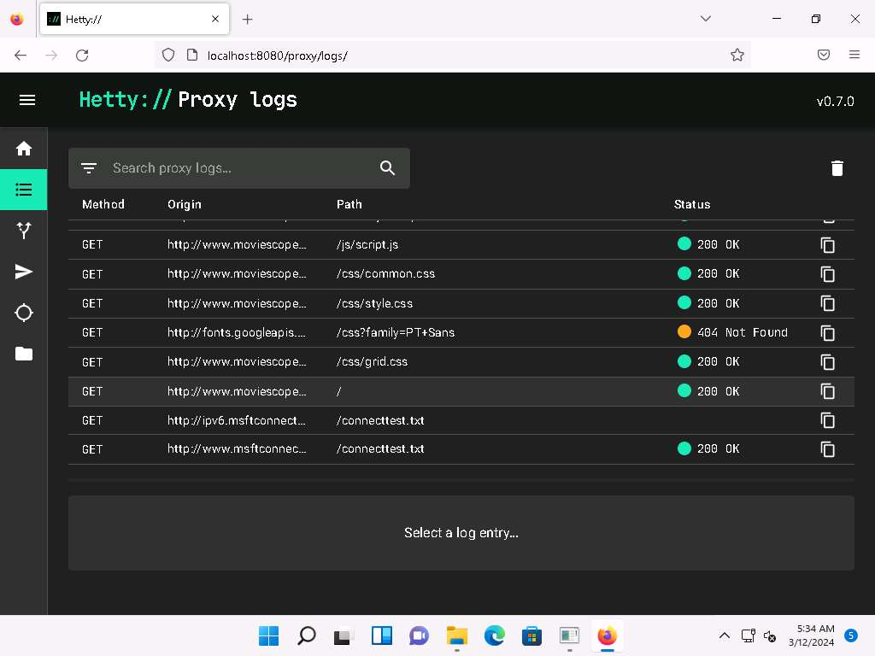
- Click Windows Server 2022 to switch back to the Windows Server 2022 machine.
- In the MovieScope website, login as a victim with credentials as sam/test.
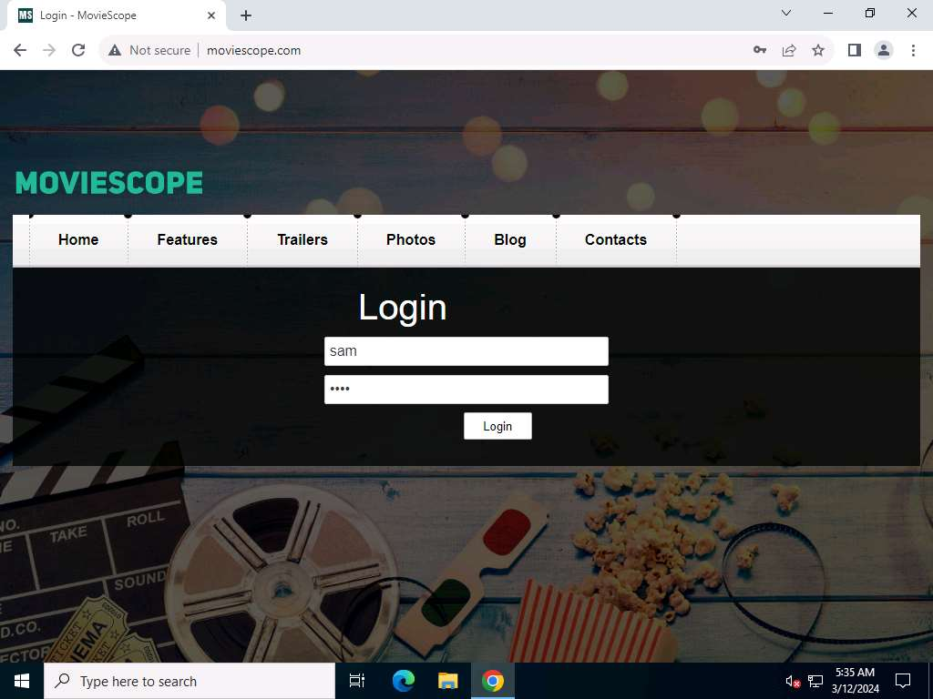
- Now, click Windows 11 to switch to the Windows 11 machine.
- In the Proxy logs page, scroll-down to check more logs on moviescope website. Check for POST log captured for the target website.
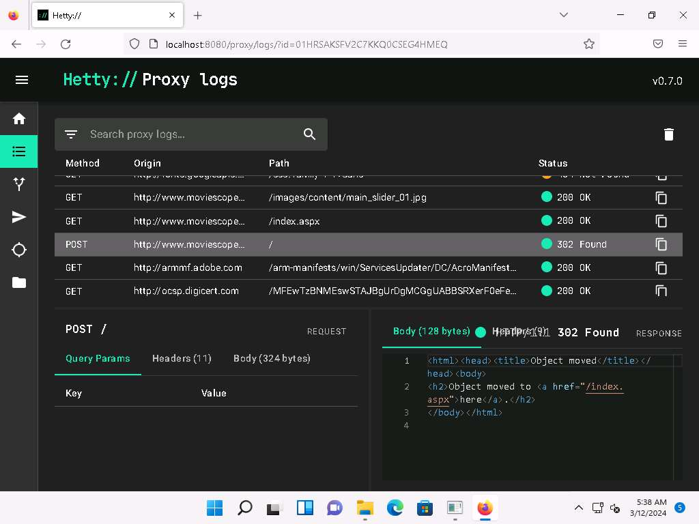
- Select the POST request and in the lower section of the page, select Body tab under POST section.
- Under the Body tab, you can observe the captured user credentials, as shown in the screenshot.
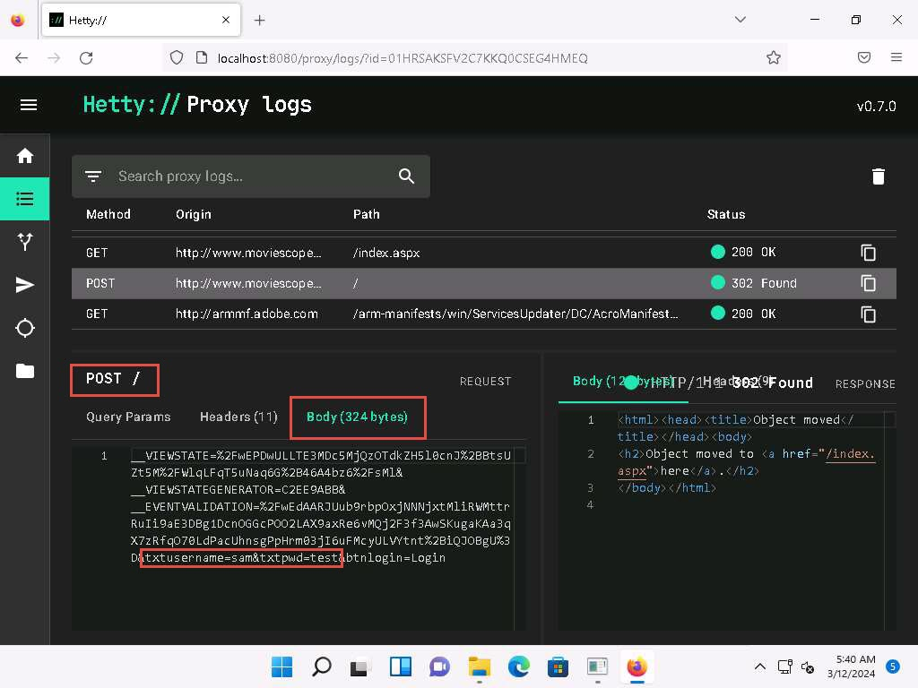
- The captured credentials can be used to log in to the target user’s account and obtain further sensitive information.
- Now, we shall change the proxy settings back to the default settings. To do so, click Windows Server 2022 to switch back to the Windows Server 2022 machine and perform Steps 13-15 again.
If you are logged out of the Windows Server 2022 machine, click Ctrl+Alt+Delete, then login using CEH\Administrator / Pa$$w0rd.
- In the Settings window, under the Manual proxy setup section in the right pane, click the On button to toggle it back to Off, as shown in the screenshot.
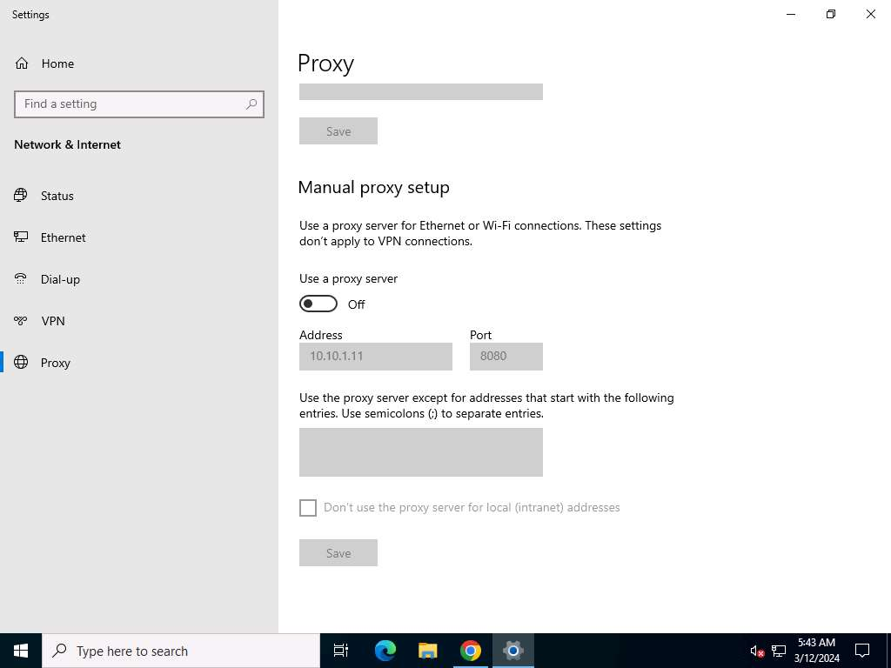
- This concludes the demonstration of HTTP traffic interception using Hetty.
- Close all open windows and document all the acquired information.
Question 11.1.2.1
Use the Hetty tool to intercept HTTP traffic on the Windows Server 2022 machine. Enter the URL that was entered in the address bar of the browser to open Hetty dashboard.
Question 11.1.2.2
Use the Hetty tool to intercept HTTP traffic on the Windows Server 2022 machine. What was the password that was captured in Hetty tool by intercepting traffic of Windows Server 2022?
Lab 2: Detect Session Hijacking
Lab Scenario
Session hijacking is very dangerous; it places the victim at risk of identity theft, fraud, and loss of sensitive information. All networks that use TCP/IP are vulnerable to different types of hijacking attacks. Moreover, these kinds of attacks are very difficult to detect and often go unnoticed unless the attacker causes severe damage. However, following best practices can protect against session hijacking attacks.
As a professional ethical hacker or penetration tester, it is very important that you have the required knowledge to detect session hijacking attacks and protect your organization’s system against them. Fortunately, there are various tools available that can help you to detect session hijacking attacks such as packet sniffers, IDSs, and SIEMs.
Lab Objectives
- Detect session hijacking using Wireshark
Overview of Detecting Session Hijacking
There are two primary methods that can be used to detect session hijacking:
- Manual Method: Involves using packet sniffing software such as Wireshark to monitor session hijacking attacks; the packet sniffer captures packets being transferred across the network, which are then analyzed using various filtering tools
- Automatic Method: Involves using Intrusion Detection Systems (IDS) and Intrusion Prevention Systems (IPS) to monitor incoming network traffic; if a packet matches any of the attack signatures in the internal database, the IDS generates an alert, and the IPS blocks the traffic from entering the database
Task 1: Detect Session Hijacking using Wireshark
Wireshark allows you to capture and interactively browse the traffic running on a network. The tool uses WinPcap to capture packets and so is only able to capture packets on networks that are supported by WinPcap. It captures live network traffic from Ethernet, IEEE 802.11, PPP/HDLC, ATM, Bluetooth, USB, Token Ring, Frame Relay, and FDDI networks. Security professionals can use Wireshark to monitor and detect session hijacking attempts.
Here, we will use the Wireshark tool to detect session hijacking attacks manually on the target system.
We will use the Parrot Security (10.10.1.13) machine to carry out a session hijacking attack on the Windows 11 (10.10.1.11) machine.
- Click Windows 11 to switch to the Windows 11 machine.
- Click the windows Search icon on the Desktop, search for Wireshark in the search bar, and launch it.
- The Wireshark Network Analyzer window appears. Start capturing the network traffic on the primary network interface (here, Ethernet).
- Now, we shall launch a session hijacking attack on the target machine (Windows 11) using bettercap.
To do so, you may either follow Steps 8-11 below or refer to Task 2 (Intercept HTTP Traffic using bettercap) in Lab 1.
- Click Parrot Security to switch to the Parrot Security machine.
- Open a Terminal window and execute sudo su to run the programs as a root user (When prompted, enter the password toor). Run cd to jump to the root directory.
- Run bettercap -iface eth0 to set the network interface.
-iface: specifies the interface to bind to (here, eth0).
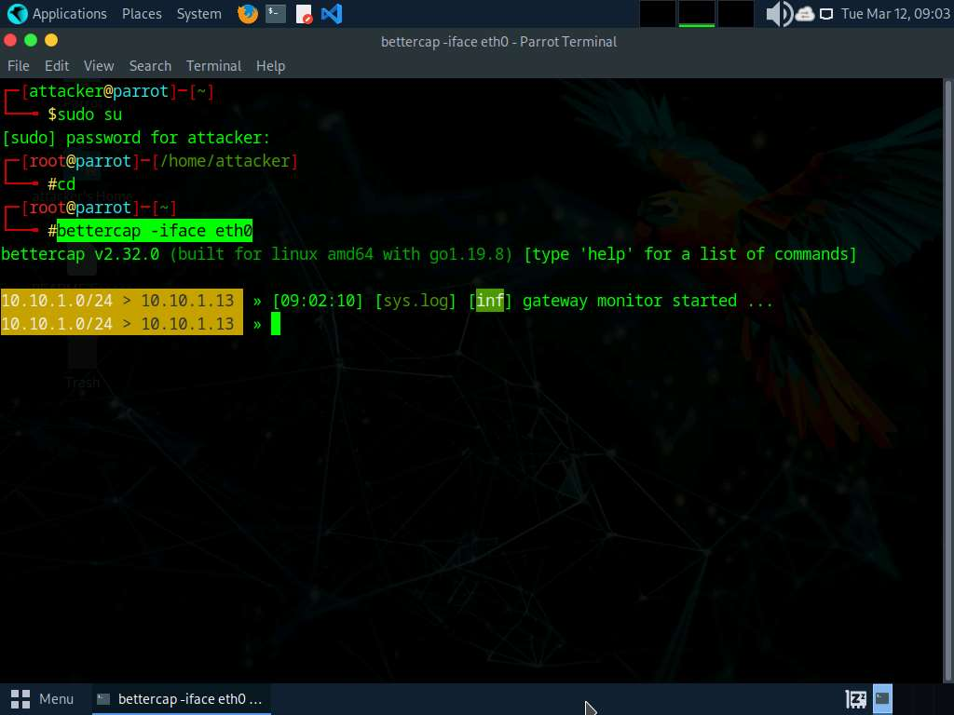
- Type net.probe on and press Enter. This module will send different types of probe packets to each IP in the current subnet for the net.recon module to detect them.
- Type net.recon on and press Enter. This module is responsible for periodically reading the system ARP table to detect new hosts on the network.
The net.recon module displays the detected active IP addresses in the network. In real-time, this module will start sniffing network packets.
- Type net.sniff on and press Enter. This module is responsible for performing sniffing on the network.
- You can observe that bettercap starts sniffing network traffic on different machines in the network, as shown in the screenshot.
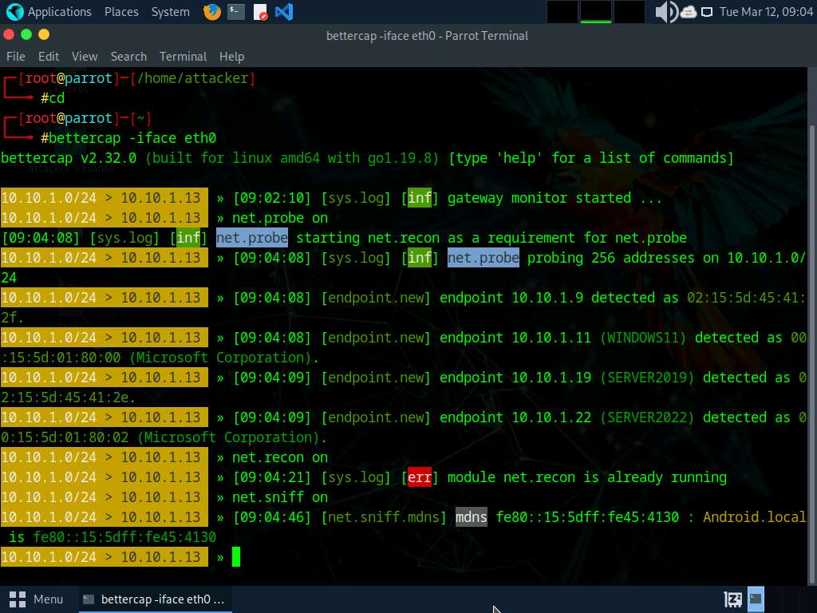
- Click Windows 11 to switch back to the Windows 11 machine and observe the huge number of ARP packets captured by the Wireshark, as shown in the screenshot.
bettercap sends several ARP broadcast requests to the hosts (or potentially active hosts). A high number of ARP requests indicates that the system at 10.10.1.13 (the attacker’s system in this task) is acting as a client for all the IP addresses in the subnet, which means that all the packets from the victim node (in this case, 10.10.1.11) will first go to the host system (10.10.1.13), and then the gateway. Similarly, any packet destined for the victim node is first forwarded from the gateway to the host system, and then from the host system to the victim node.
more...
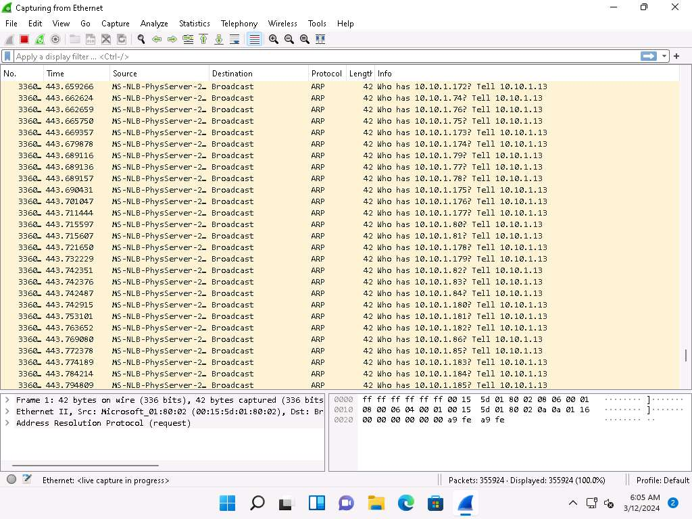
- This concludes the demonstration of how to detect a session hijacking attack using Wireshark.
- Close all open windows and document all the acquired information.
Question 11.2.1.1
Use the bettercap tool (available in the Parrot Security machine) to sniff the traffic on the target system (10.10.1.11). Use the Wireshark tool on the target system (10.10.1.11) to detect the session hijacking attempt. Traffic on which protocol indicates the session hijacking attempt in Wireshark?

